
Data Collection and Preprocessing Phase
Date | 20 June 2024
Team ID | 739900
Project Title | Predicting Permanent Magnet Resistance Of Electronic Motor Using Machine Learning.
Maximum Marks | 6 Marks

Data Exploration and Preprocessing Report :
Dataset variables will be statistically analyzed to identify patterns and outliers, with Python employed for preprocessing tasks like normalization and feature engineering. Data cleaning will address missing values and outliers, ensuring quality for subsequent analysis and modeling, and forming a strong foundation for insights and redictions.


Univariate Analysis
Section
Data
Overview

Description
Dimension:
28115rows × 9 Columns Descriptive
Descriptive statistics:
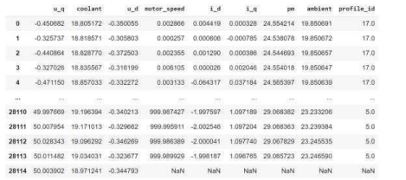


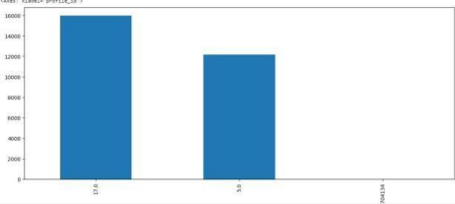


Multivariate Analysis

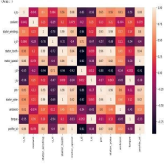
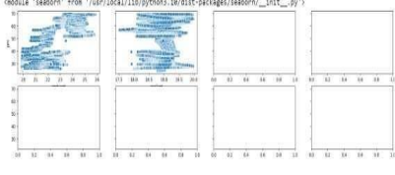

Outliers and
Anomalies

-
Data Preprocessing Code Screenshots

Loading Data

Handling
Missing Data


data=pd.read_csv("/content/measures_v2.csv")
df.head()

Data
Transformation
Feature
Engineering
Save
Processed Data -

-----
Attached the codes in final submission.

